FRENCH & FRANCOPHONE STUDIES RESEARCH TALK

‘Legacies of Slavery in the French Republic:
Recognition, Reconciliation or Reparation?’

Dr Nicola Frith (University of Edinburgh)

5pm, Tues 25 April, room G.03 Jessop West

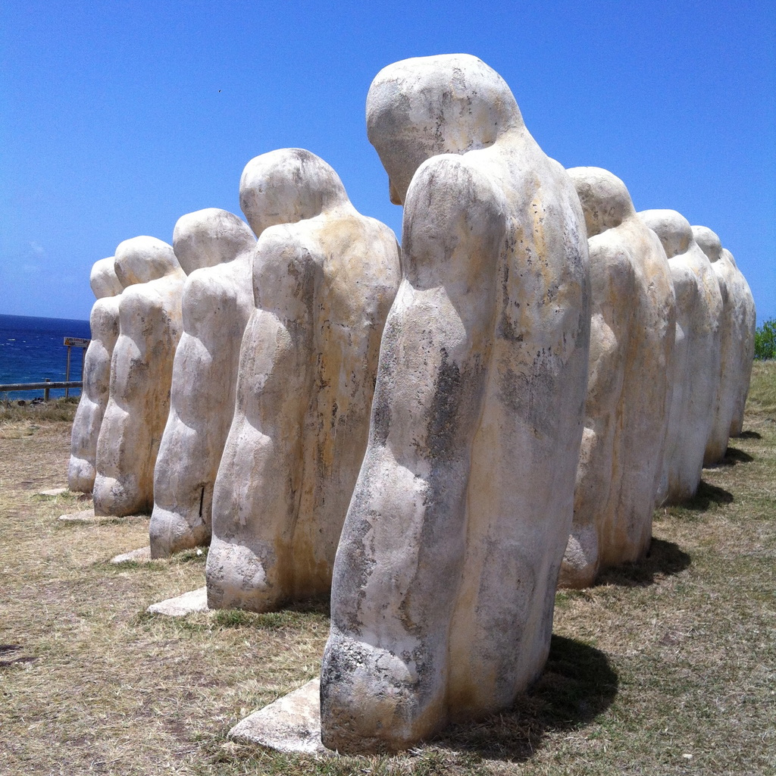
Anse Cafard Slave Memorial, Martinique

The overall aim of this paper will be to showcase some of the main lines of debate around the memories and legacies of slavery in the French Republic today, while exploring the extent to which ‘reconciliation’ is being used to serve elite interests in contrast to reparations that seek to address ongoing racial inequalities today.

